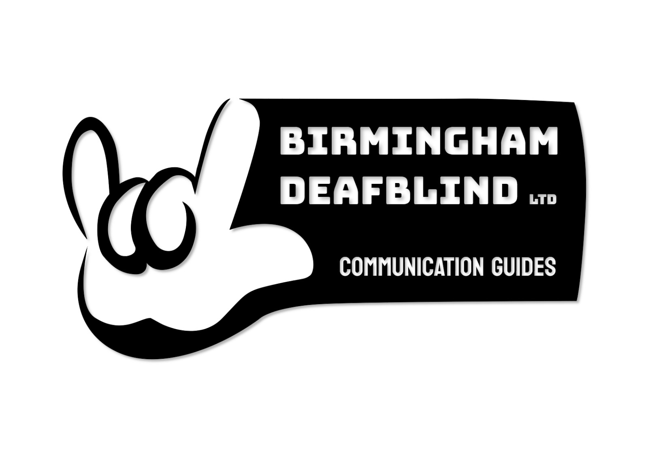

Birmingham Deafblind (BDB)
Recruitment & Compliance Form
Thank you for your interest in working with BDB.
This form collects essential information to support safer recruitment and helps us ensure we meet safeguarding responsibilities.

About BDB
BDB provides personalised, one-to-one support for adults who are Deaf, blind, or Deafblind.
Our services focus on promoting independence, inclusion, wellbeing, and community access. Support may include community access, social activities, appointments, practical support, and communication support.
BDB is committed to safeguarding, equality, dignity, and respect in all aspects of our work.

Section 1: Personal Details
Full Name: | Click or tap here to enter text.
Preferred Name: | Click or tap here to enter text.
Date of Birth: | Click or tap here to enter text.
Address: | Click or tap here to enter text.
Contact Number: | Click or tap here to enter text.
Email: | Click or tap here to enter text.

Section 2: Availability
What days are you available to work (STC)?
☐ Monday
☐ Tuesday
☐ Wednesday
☐ Thursday
☐ Friday
☐ Saturday
☐ Sunday

What times are you available (STC)?
Click or tap here to enter text.

Day | Morning | Afternoon | Evening
Monday | ☐ | ☐ | ☐
Tuesday | ☐ | ☐ | ☐
Wednesday | ☐ | ☐ | ☐
Thursday | ☐ | ☐ | ☐
Friday | ☐ | ☐ | ☐
Saturday | ☐ | ☐ | ☐
Sunday | ☐ | ☐ | ☐

Are you willing to work:
☐ Weekdays
☐ Weekends
☐ Evenings
☐ Bank Holidays
☐ Flexible Hours

Do you have access to transport?
☐ Own Vehicle
☐ Public Transport
☐ Other (please specify):
Click or tap here to enter text.

Are you willing to travel within Birmingham and surrounding areas?
☐ Yes
☐ No

If yes, please provide any travel limitations:
Click or tap here to enter text.

Driving & Insurance Requirements
If you intend to use your own vehicle to support BDB citizens, you will be required to have appropriate motor insurance that includes business use. Alternatively, you may use public transport while supporting BDB citizens.
It is the responsibility of the recruit to ensure that:
- Their vehicle is insured for business-related travel undertaken on behalf of BDB.
- Their vehicle is roadworthy, taxed and has a valid MOT (where applicable).
- They hold a valid UK driving licence.
Do you have a full UK driving licence?
☐ Yes
☐ No

Do you have access to a vehicle for work purposes?
☐ Yes
☐ No

If yes, does your motor insurance currently include business use?
☐ Yes
☐ No

If not, would you be willing to obtain appropriate business-use insurance if required for the role?
☐ Yes
☐ No

Please provide any additional information about your availability:
Click or tap here to enter text.

Section 3: Right to Work in the UK
Please confirm your right to work in the UK:
☐ UK / Irish Citizen
☐ Settled / Pre-Settled Status
☐ Visa (please specify):
Click or tap here to enter text.

Documents seen (office use): ☐ Yes ☐ No

Section 4: DBS (Disclosure and Barring Service)
An enhanced DBS check is required for this role.
Do you currently have a valid Enhanced DBS?
☐ Yes
☐ No

If yes:

DBS certificate number:
Click or tap here to enter text.

Date DBS was issued:
Click or tap here to enter text.

Is your DBS registered with the Update Service?
☐ Yes
☐ No

Section 5: References (Two Required)
Please provide details for two referees (at least one should be a previous employer or professional reference).
Consent to Contact Referees
By providing the details below, I give BDB permission to contact the named referees as part of the recruitment process.
☐ I consent to BDB contacting the referees named in this application.
Reference 1
Name: | Click or tap here to enter text.
Organisation: | Click or tap here to enter text.
Relation to You: | Click or tap here to enter text.
Email Address: | Click or tap here to enter text.
Telephone Number: | Click or tap here to enter text.

Reference 2
Name: | Click or tap here to enter text.
Organisation: | Click or tap here to enter text.
Relation to You: | Click or tap here to enter text.
Email Address: | Click or tap here to enter text.
Telephone Number: | Click or tap here to enter text.

Section 6: Communication Skills & Experience
Please indicate any communication methods you are familiar with:
☐ British Sign Language (BSL)
☐ Deafblind Manual
☐ Hands-on Signing
☐ Makaton
☐ Lipreading Support
☐ Other (please specify)
☐ None of the Above

Section 7: Relevant Experience & Skills
Please briefly outline any relevant experience, training, or skills related to supporting Deaf, blind, or Deafblind adults (or other care/support roles):
Click or tap here to enter text.

Section 8: Safeguarding Declaration
BDB has a duty to safeguard adults at risk. Please answer the following:
Have you ever been:
Subject to a safeguarding investigation?
☐ Yes
☐ No

Disciplined or dismissed from a role involving vulnerable adults?
☐ Yes
☐ No

If yes, to either question, please provide details:
Click or tap here to enter text.

Section 9: Declaration
I confirm that the information provided is true and accurate to the best of my knowledge. I understand that providing false information may result in withdrawal of an offer or termination of engagement.
Print Name: | Click or tap here to enter text.
Signature: | Click or tap here to enter text.
Date: | Click or tap here to enter text.

Please return the completed form and any requested documents to info@birminghamdeafblind.co.uk
Office use only
- DBS verified: ☐ Yes ☐ No
- References received: ☐ ☐ 2

